**MBC 652/ACC 452**

**Final Project**

**Remote Work & Mental Health**

Chyiane Bynum - Andrew Feingold - Anna Heron –

Pranav Mahesh Mekal - Owen Truppo - Cecilia Vicil

17 December 2024

**Table of Contents**

Background: 3

Problems that need to be addressed: 3

Applying the IMPACT Cycle 4

Identify Questions: 4

Master the Data: 6

Perform Test Plan: 7

Address and Refine Results: 10

Communicate Insights: 11

Track Outcomes: 13

Future Recommendations for Tracking 15

# Background:

The dataset explores the impact of remote work on employees' mental well-being across various industries and regions. With 5,000 records collected globally, it includes data on work location, stress levels, access to mental health resources, job satisfaction, and other factors. This data provides valuable insights for organizations aiming to improve employee well-being and productivity in remote, hybrid, or onsite work setups. The dataset offers a comprehensive view of how different factors influence stress, mental health, and job satisfaction, making it a key resource for decision-making.

# Problems that need to be addressed:

1. **Stress Management:** How can the organization effectively reduce stress and improve mental health conditions for remote workers?
2. **Productivity Optimization:** What strategies can the organization adopt to maximize productivity for employees working in remote or hybrid settings?
   * Differences in productivity changes (increase, decrease, no change) are observed across work locations. Organizations may need to optimize work setups to enhance productivity.
3. **Remote Work Satisfaction**: How can the organization improve satisfaction and provide better support to employees working remotely?
   * Employees report different levels of satisfaction with remote work, and company support for remote work varies. Low satisfaction and inadequate support can impact morale and retention.

# Applying the IMPACT Cycle

## Identify Questions:

To address the identified problems—**Stress Management**, **Productivity Optimization**, and **Remote Work Satisfaction**—we divided the analysis into **Descriptive**, **Diagnostic**, and **Predictive** questions to provide a comprehensive understanding of the dataset.

1. **Stress Management**

**Descriptive Questions**

* What is the percentage of employees experiencing high, medium, or low stress?
* How do stress levels differ across work locations (remote, hybrid, onsite)?

**Diagnostic Questions**

* How does access to mental health resources impact stress levels?
* What factors (e.g., work-life balance, isolation, workloads) are most correlated with high stress?

**Predictive Questions**

* How will stress levels change if more mental health resources are introduced?
* What is the expected reduction in stress levels if work-life balance improves by 1 point on the scale?

1. **Productivity Optimization**

**Descriptive Questions**

* What is the distribution of productivity changes (increase, decrease, or no change) across different work environments (remote, hybrid, onsite)?
* What are the average productivity levels in each work location?

**Diagnostic Questions**

* How do stress levels and social isolation ratings impact productivity?
* What role does access to mental health resources play in changes to productivity?

**Predictive Questions**

* If hybrid environments address communication and collaboration challenges, what is the projected improvement in productivity?
* How likely is productivity to decrease further if mental health resources are not provided?

1. **Remote Work Satisfaction**

**Descriptive Questions**

* What percentage of employees are satisfied, neutral, or unsatisfied with remote work arrangements?
* How does satisfaction vary across work locations (remote, hybrid, onsite)?

**Diagnostic Questions**

* How does company support influence employee satisfaction with remote work?
* What factors (e.g., social isolation, career progression, work-life balance) drive dissatisfaction with remote work?

**Predictive Questions**

* What level of employee satisfaction can be expected if company support improves by one level on the satisfaction scale?
* How will dissatisfaction rates change if social isolation ratings decrease?

## Master the Data:

To ensure a meaningful and accurate analysis, the dataset was carefully reviewed, structured, and prepared for visualization and modeling. This process was essential for addressing the **Descriptive**, **Diagnostic**, and **Predictive** questions outlined earlier. The dataset included 5,000 records, capturing critical variables such as work location (remote, hybrid, onsite), stress levels (high, medium, low), access to mental health resources, productivity changes, social isolation ratings, work-life balance ratings, satisfaction with remote work, and company support for remote work.

The data preparation process began with a thorough review to check for inconsistencies or missing values. Since the dataset was already cleaned prior to acquisition, no significant data cleaning was required. For categorical variables like **Stress Level** and **Work Location**, we ensured entries were standardized, and where necessary, transformed into numeric codes to facilitate analysis. Variables such as **Work-Life Balance Rating** and **Social Isolation Rating** were retained as ordinal scales to preserve their interpretative value.

To enable deeper insights, additional calculations and measures were introduced. Average stress levels were segmented by work location, and the distribution of productivity changes (increase, decrease, no change) was examined across remote, hybrid, and onsite work environments. Relationships between company support and employee satisfaction with remote work were also calculated to identify possible correlations. Furthermore, the percentage of employees reporting high stress levels was analyzed to provide a clearer understanding of the magnitude of the issue.

The data was then structured for visual analysis using **Power BI**. Interactive features, including drill-down capabilities and calculated measures, were incorporated to enhance the interpretation of key trends. Visualizations such as bar charts and pie charts were used to represent insights on stress, productivity, and satisfaction across different work environments.

During this stage, it became evident that many variables lacked strong variability, which posed challenges for predictive modeling. For example, stress levels, work-life balance ratings, and company support scores were often clustered around the midpoints of their scales. This limited variability reduced the strength of relationships between features, making it difficult to identify clear predictive trends.

## Perform Test Plan:

The dataset comprises a mix of categorical and numerical variables, which were analyzed using statistical methods and visualizations to uncover insights related to stress, productivity, and satisfaction with remote work. Key variables, such as **Stress Level**, **Satisfaction with Remote Work**, and **Productivity Changes**, were transformed where necessary to enable effective analysis. For instance, **Stress Levels** and **Satisfaction with Remote Work** were assigned numerical values using lookup tables, making them easier to process in statistical models.

|  |  |
| --- | --- |
| **VARIABLE** | **MEAN** |
| Age | 40.995 |
| Years of Experience | 17.8102 |
| Hours worked per week | 39.6146 |
| Number of virtual meetings | 7.559 |
| Work life balance rating (1-5) | 2.9842 |
| Stress level (1-3) | 2.0082 |
| Social Isolation rating (1-5) | 2.9938 |
| Satisfaction with remote work (1- (1)) | -0.0004 |
| Company support for remote work (1-5) | 3.0078 |

To understand overall trends, we calculated the **mean** for key variables: age, years of experience, hours worked per week, number of virtual meetings, work-life balance rating, stress level, social isolation rating, satisfaction with remote work, and company support for remote work. The results showed that most variables were centered around the midpoints of their scales. For example, the average work-life balance rating was **2.98** (on a scale of 1–5), and the average stress level was **2.00** (on a scale of 1–3). Similarly, social isolation and company support ratings hovered around **3.00**, suggesting a lack of strong variability within the data.

These initial observations revealed a significant challenge for predictive modeling. With many variables clustered around the midpoints, the dataset exhibited limited variability, making it difficult to identify strong patterns or trends. This issue was compounded by the absence of more granular features, such as specific industry-related stressors or regional variations, which could have provided additional depth to the analysis.

Despite these challenges, we performed regression analysis to evaluate the relationships between key predictors and outcomes. For example, we examined how factors such as **work-life balance**, **social isolation**, and **company support** influenced stress levels, productivity, and satisfaction. The regression results showed an F significance greater than 0.05, meaning that this analysis was inconclusive and cannot provide any information from it. This further reinforced the idea that the dataset lacked sufficient feature variability for building robust predictive models.

In summary, while the data offered valuable insights through descriptive and diagnostic analyses, its limited variability hindered the development of a reliable predictive model. Access to a larger dataset or data from a more specific niche could potentially uncover a meaningful and valid relationship.

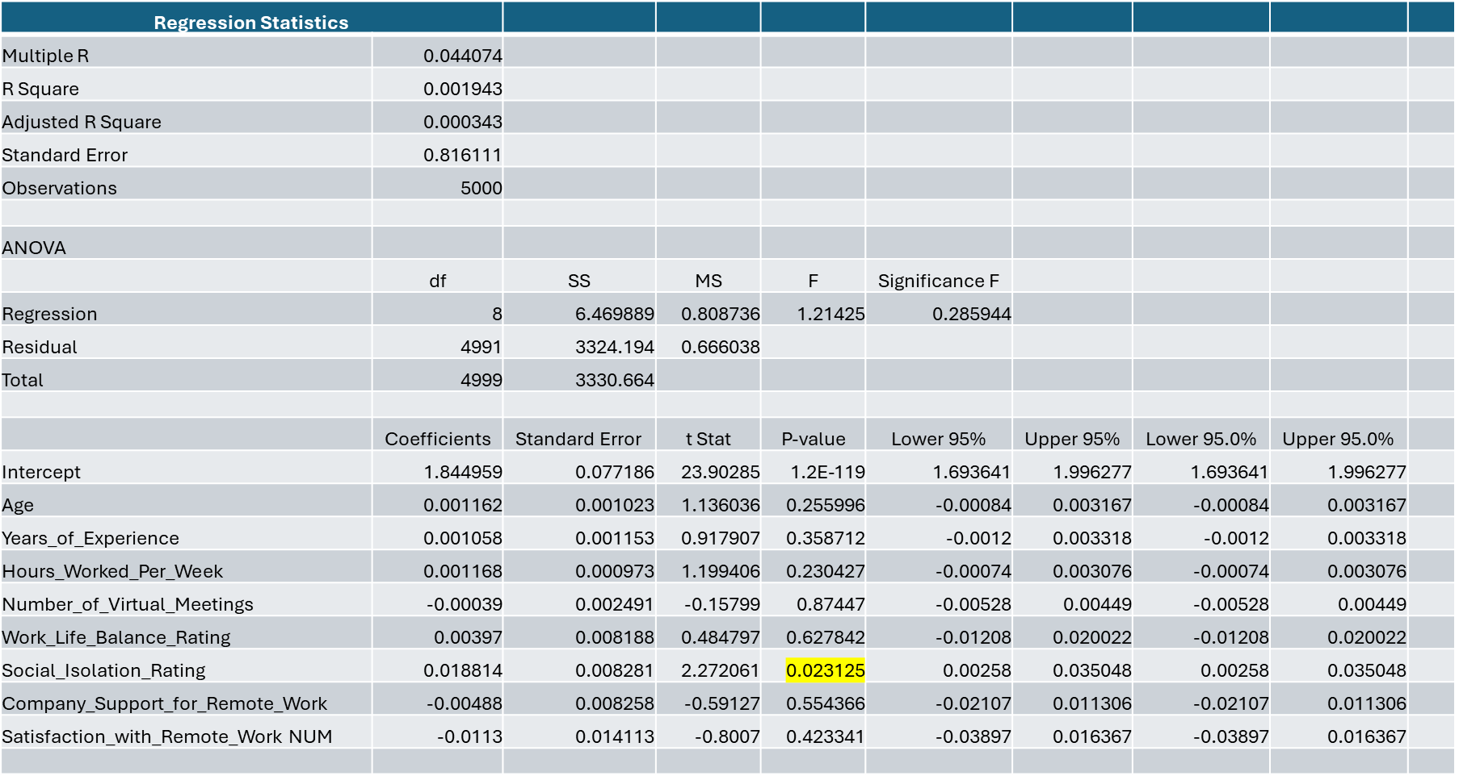

## Address and Refine Results:

The dataset provides valuable insights into the relationship between work environments, mental health, and employee satisfaction. Collected from 5,000 individuals across various industries (e.g., Consulting, Education, Finance, Healthcare, IT, Manufacturing, and Retail) and regions (Africa, Asia, Europe, North America, Oceania, and South America), the data offers a global perspective on the impact of remote work. However, while the dataset has breadth, its diversity posed challenges for refining insights.

A key limitation was the **lack of variability in certain features**, such as stress levels, work-life balance ratings, and satisfaction scores. Most of these variables were clustered near their midpoint values, suggesting a limited ability to identify distinct trends or make robust predictions. Additionally, the dataset’s generality across industries and regions made it difficult to derive insights tailored to specific organizational contexts. For example, stressors unique to industries like healthcare or IT, or cultural differences influencing work-life balance, were not fully captured.

To address these issues, we recommend that future datasets focus on **more specific cohorts**, such as individuals within a single industry or region. This targeted approach would enable deeper insights and allow organizations to implement solutions tailored to the unique needs of their workforce. Furthermore, collecting additional features, such as detailed information on mental health policies, technological support, and individual job roles, could help refine predictive models and uncover stronger relationships.

Despite these challenges, the dataset was structured to maximize its potential. Descriptive analysis provided an overview of stress, productivity, and satisfaction levels across work environments, while diagnostic analysis revealed key factors influencing these outcomes. Although predictive models were constrained by the limitations of the data, they offered directional insights that organizations could use as a starting point for decision-making.

In summary, while the dataset's scope enabled a broad understanding of employee well-being in remote work setups, its generality and lack of variability highlighted areas for improvement. Future studies should aim to collect more specific and nuanced data to generate actionable and precise recommendations.

## Communicate Insights:

The analysis provided valuable insights into how remote work setups impact stress, productivity, and satisfaction. While challenges in predictive modeling limited the precision of forecasts, the findings from descriptive and diagnostic analyses offer actionable recommendations for organizations seeking to improve employee well-being.

**Stress Levels**

Approximately **34% of employees** reported experiencing high stress levels, primarily driven by factors such as heavy workloads, poor work-life balance, and social isolation. These stressors were particularly pronounced in remote and hybrid work environments, where boundaries between personal and professional life often blur.

Organizations can mitigate these stressors by:

* Providing **robust mental health resources**, such as access to counseling and wellness programs.
* Promoting **flexible schedules** to help employees manage work-life boundaries.
* Encouraging practices that prioritize **work-life balance**, such as setting clear expectations for work hours and minimizing after-hours communication.

**Productivity Patterns**

Employees in **hybrid work environments** reported the lowest productivity levels compared to their fully remote or onsite counterparts. Challenges such as miscommunication, lack of collaboration, and unclear expectations were identified as key barriers to productivity in hybrid setups.

To address these issues, organizations should:

* Foster an **inclusive hybrid work culture** that emphasizes clear communication and collaboration.
* Invest in **collaboration tools** that reduce friction in hybrid workflows.
* Provide **training and resources** to help employees adapt to the unique demands of hybrid work environments.

**Remote Work Satisfaction**

Only **33.5% of employees** reported being satisfied with remote work arrangements. Dissatisfaction was linked to factors such as limited career development opportunities, reduced social interaction, and challenges in maintaining work-life balance.

To enhance satisfaction, organizations can:

* Create opportunities for **virtual networking** and informal interactions among employees to combat isolation.
* Offer **career development programs** tailored to remote workers, ensuring they feel valued and supported in their professional growth.
* Equip employees with the necessary tools and resources for effective **home office setups** to minimize distractions and improve productivity.

**Key Challenges in Predictive Modeling**

The analysis revealed that predictive modeling was constrained by the dataset’s lack of variability, as many features—such as stress levels, satisfaction scores, and company support ratings—were clustered around their midpoints. As a result, the relationships between variables were weak, limiting the accuracy and reliability of predictions.

Future efforts should aim to collect more **granular data** with greater variability, such as industry-specific stressors or regional differences, to enhance the predictive power of models and support more precise decision-making.

## Track Outcomes:

The findings of this analysis highlight several key areas where organizations can intervene to improve employee well-being, productivity, and satisfaction. Tracking the outcomes of implemented changes will be critical to understanding their effectiveness and refining strategies over time.

**Stress Management**

Approximately **34% of employees** report experiencing high stress levels, with contributing factors including heavy workloads, poor work-life balance, and social isolation. Chronic stress not only affects employees’ mental and physical well-being but also reduces productivity, engagement, and job satisfaction. If left unaddressed, high stress levels may lead to burnout, absenteeism, and increased turnover rates, ultimately disrupting organizational productivity.

To track progress, organizations should:

* Monitor trends in **stress levels** across work environments (remote, hybrid, onsite) before and after introducing interventions such as mental health resources or flexible scheduling.
* Collect employee feedback through **regular surveys** to assess the perceived effectiveness of new policies or programs.
* Measure changes in **employee turnover and absenteeism rates** as indirect indicators of stress reduction.

**Productivity Optimization**

The analysis revealed that employees in **hybrid setups** experience the lowest productivity levels, largely due to challenges in communication, collaboration, and accountability. Addressing these barriers is essential to improving productivity.

To track outcomes, organizations can:

* Regularly evaluate **productivity metrics**, such as task completion rates and project deadlines, across different work environments.
* Analyze the impact of **collaboration tools** and training programs on productivity improvements in hybrid teams.
* Monitor **employee engagement scores** to assess whether the hybrid work culture fosters collaboration and motivation.

**Remote Work Satisfaction**

With only **33.5% of employees** expressing satisfaction with remote work arrangements, there is significant room for improvement. Addressing dissatisfaction factors, such as limited social interaction and career development opportunities, is essential to improving morale and retention.

To measure progress, organizations can:

* Track changes in **satisfaction ratings** through annual employee satisfaction surveys.
* Monitor participation rates in **virtual networking events** and **professional development programs**, using them as indicators of employee engagement.
* Evaluate the impact of enhanced remote work support (e.g., better home office setups) on overall satisfaction and productivity.

## ****Future Recommendations for Tracking****

To ensure continuous improvement, organizations should implement a robust **feedback loop** that collects, analyzes, and acts on employee input regularly. By combining survey results, productivity metrics, and turnover rates, they can develop a holistic understanding of the effectiveness of their interventions. This iterative process will help organizations adapt to evolving employee needs and maintain a motivated, productive workforce.